**Questions**

1. The following image is the SWR plot of a cable used between the RF port and the antenna on LTE eNodeB operating on the PCS cellular band. Will the installation pass the acceptance test? Explain why?

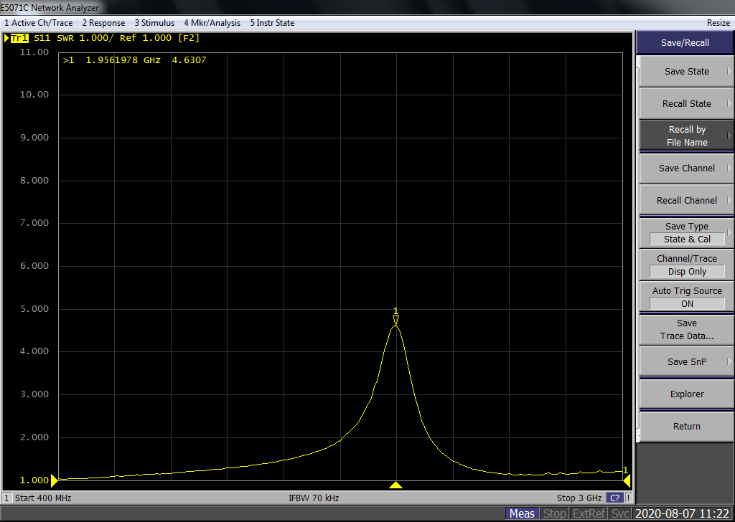

1. Find a matching network with ZL=150+150j Ω and Zin=50Ω (Assume line impedence ZO=50Ω) using smith chart.
2. Convert the inductor to equivalent stub line
3. A load has an impedance ZL = 45 + j75 and the system reference impedance, Z0 is 100 . Calculate the VSWR and reflection coefficient.
4. Compute the total system gain in dB for the system shown in Figure. If the input power is 150 mW, what is the output power in dBm?



1. The carrier level of a signal with both AM and FM is 0.1 V. The upper sideband amplitude is 0.05 V, and the lower sideband amplitude is 0.02 V. Estimate the AM and FM modulation indexes.
2. What are the values of reflection coefficient, return loss, and SWR for the special cases of a shorted load and an open load?